ATTN: XXXXX
Customize this press release by adding your club’s information, correcting anything that doesn’t fit with your club plans, and if desired by replacing the pictures with your own.
For immediate release
Date: XXXX City, State XXXX

Rotary Club of XXXX urges COVID-19 Vaccinations with Smiley Faces
Rotary Clubs in Kansas and Oklahoma are responding to the COVID-19 crisis with an attention grabbing display of smiles. Rotary District Governor-Elect Fred Heismeyer says, “People can’t see a smiley face without smiling themselves and that happy moment is sorely needed in these days of isolation and quarantine.”
“Sharing Smiles” was conceived by Rotarian DeAnn Sullivan of Wichita to help draw attention and maintain a focus on the need for getting a vaccine. The “Smiley” kits were purchased through a grant from the Kansas Leadership Center and designed to help spread the word to get vaccinated. Kits of 8-10 smiley face signs and 2 rectangular signs are available to be temporarily set up at events, in the yards of supporters and in other locations throughout town to catch attention of passing motorists and urge them to “Get Vaccinated” to help stop the spread of COVID-19. The displays will be installed and rotated by volunteer Rotarians throughout town on a regular basis.
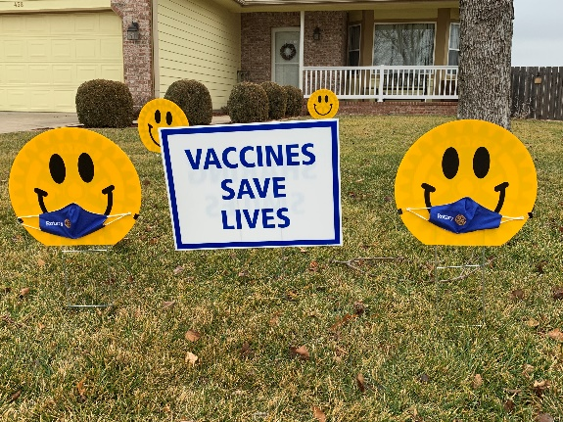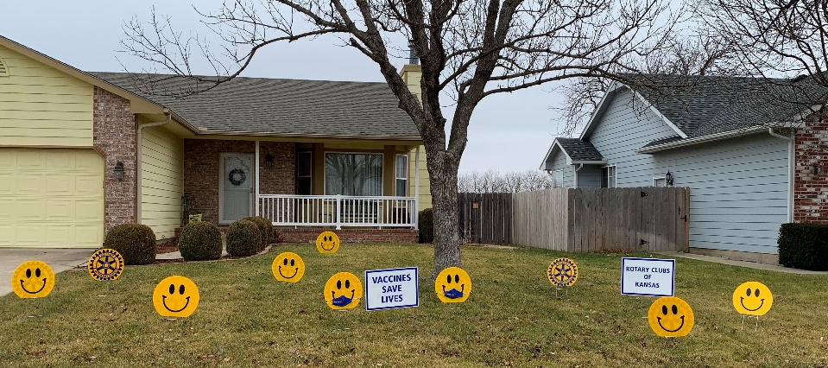
(sample)

Rotary is a global network of 1.2 million neighbors, friends, leaders, and problem-solvers who see a world where people unite and take action to create lasting change – across the globe, in our communities, and in ourselves. Our 35,000+ clubs provide service to others; promote integrity, and advance world understanding, goodwill, and peace through our fellowship of business, professional, and community leaders.

Smiley kits are available for loan by calling or emailing the contact below:
Name: (Insert Club Coordinator information).
Phone:
Email:
###

